1. 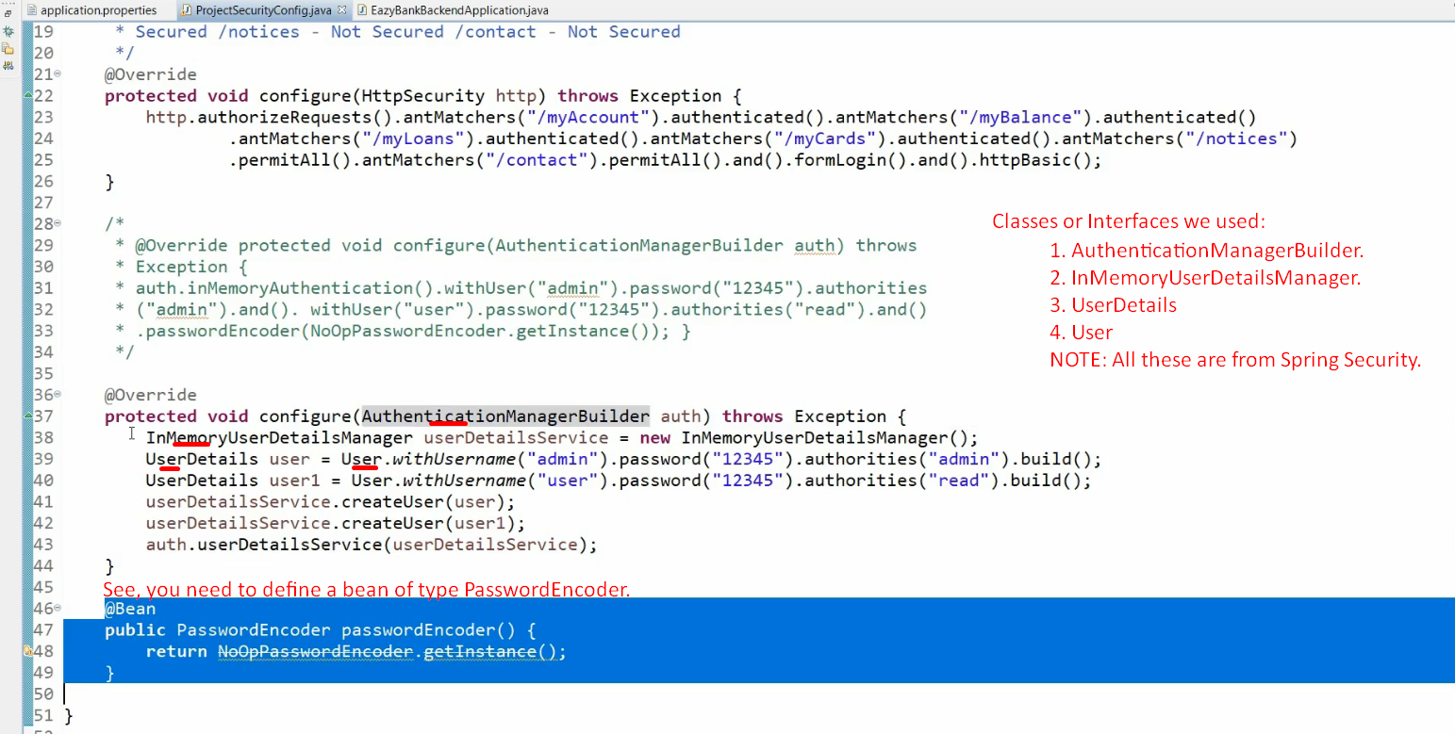
2. **NOTE**: The way we have defined in memory user details in this lecture is different from that in previous lecture but technically both are same.

This way of defining gives a clear picture of how to define in memory user details.